|  |  |
| --- | --- |
| Date | 10 Nov 2022 |
| Team ID | PNT2022TMID51155 |
| Project Name | Smart Fashion Recommender Application |
| Team Members: | Karthik Muneeswaran M  Gowtham Prabakar S  Mohammed Sithik M  Muthu Kumar M  Aswanth R |

Sendgrid Open Page:



Sendgrid login Page:

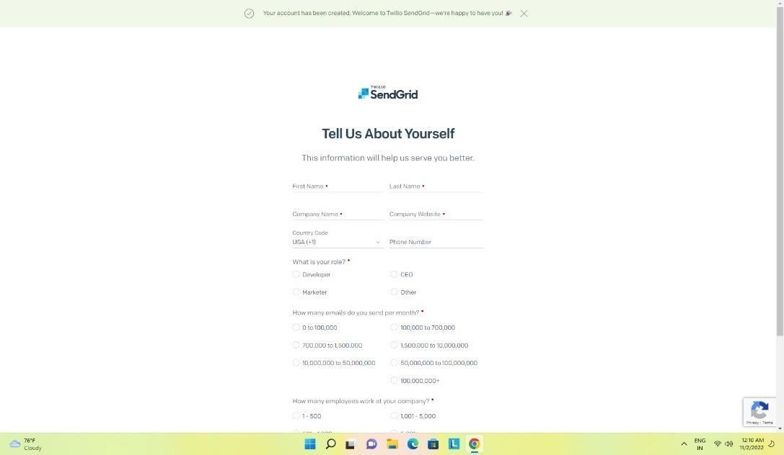

Sendgrid successfully created:

